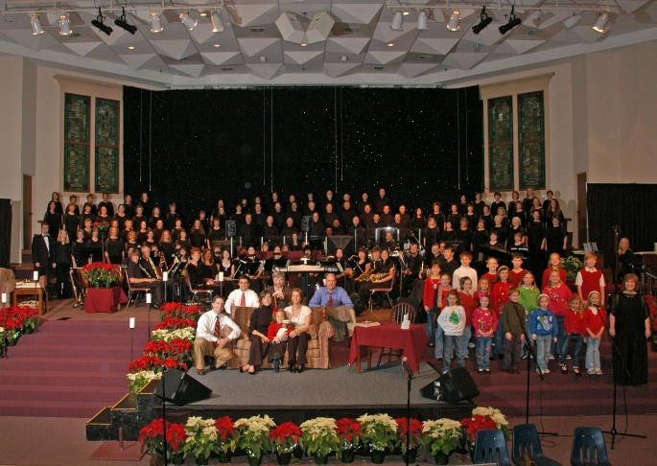

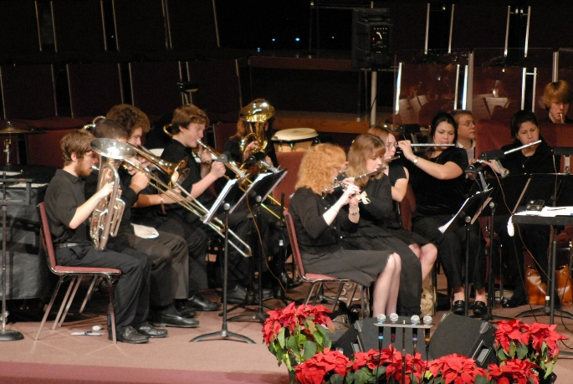

Worship Choir Handbook
© 2008 Collierville First Baptist Church. All rights reserved.
No part of this publication may be reproduced in any form without the prior written permission of the publisher.
Collierville First Baptist Church
Worship Ministry
830 New Byhalia Rd. • Collierville, TN 38017
901-853-2668 • Prayer Line 312-3474
www.CFBConline.com

Worship Choir Handbook
Collierville First Baptist Church

Welcome!
I am so glad you’ve decided to be a part of the Worship Choir & Orchestra ministry here at Collierville First Baptist Church. Week in and week out, there is nothing more important in the life of our church than our Sunday morning worship celebrations. It’s a time for renewal, motivation, encouragement and, most of all, worth-ship—an opportunity to show God how much He means to us. Thank you for your commitment to rehearsal and Sunday services!

The Heart of Worship
An awareness of the greatness and power of God is at the heart of worship, whether your own private time with God or the time we share together as a group. Our hope at CFBC is to continually strive for Psalm 100 worship...

Shout for joy to the LORD, all the earth. Worship the LORD with gladness; come before him with joyful songs...Enter his gates with thanksgiving and his courts with praise;...For the LORD is good and his love endures forever; his faithfulness continues through all generations (NIV).

As you “shout for joy to the LORD” and offer up “thanksgiving and praise” each Sunday, I pray that God will use your offerings of worship to bless our church and our community.

God bless you as you use your gifts at CFBC!

In Christ,
Worship Ministry Leadership Team
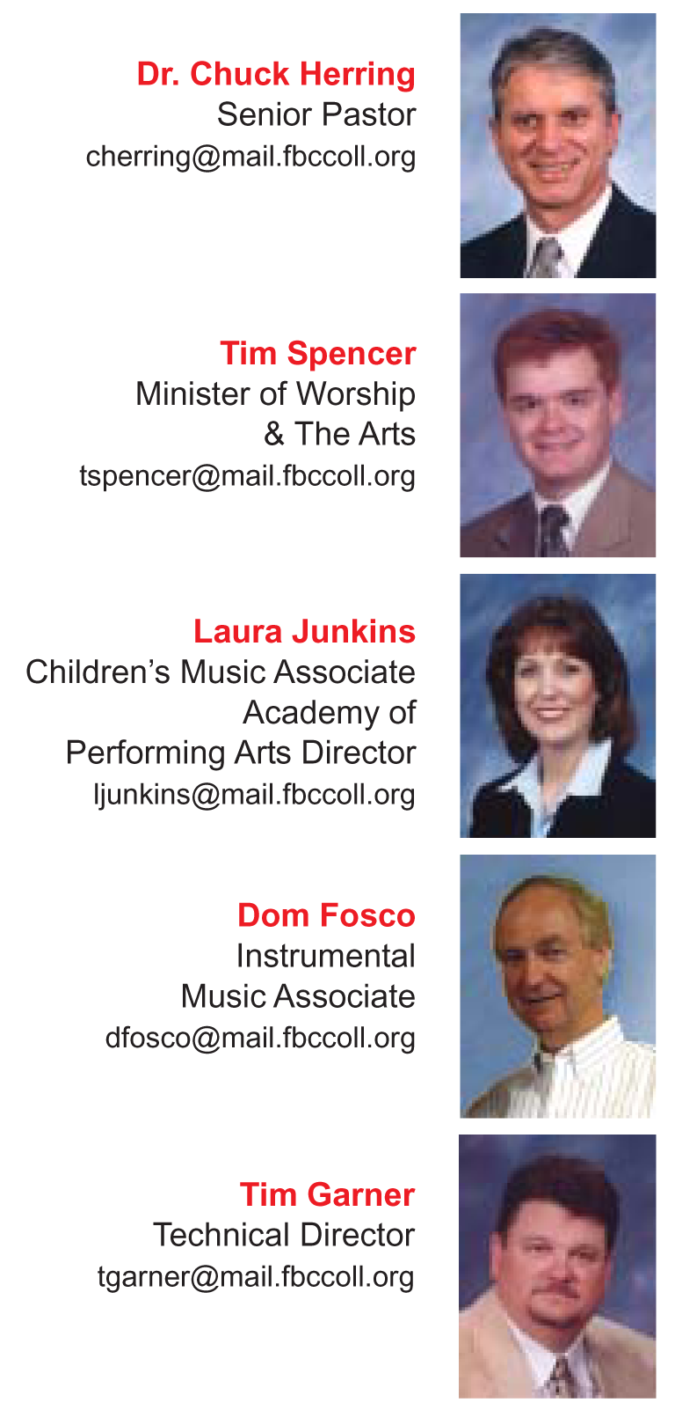
CFBC Leadership Team

Senior Pastor Dr. Chuck Herring cherring@fbccoll.org
Associate Pastor Dr. Tommy Vinson tvinson@fbccoll.org

Maturity & Ministry
Education/Discipleship Mark LaGrone mlagrone@fbccoll.org
Preschoolers Doris Sams dsams@fbccoll.org
Adults 55+/Recreation Les Helton lhelton@fbccoll.org
Children Austin Whittington awhittington@fbccoll.org
High School Students Al Baker abaker@fbccoll.org
Middle School Students Michael Mewborn mmewborn@fbccoll.org
College/Young Singles Matt Hess mhess@fbccoll.org

Worship
Worship & The Arts Tim Spencer tspencer@fbccoll.org
Children’s Music Laura Junkins
Academy of ljunkins@fbccoll.org

Performing Arts
Instrumental Music Dom Fosco dfosco@fbccoll.org
Technical Ministry Tim Garner tgarner@fbccoll.org

Missions
Missions/Administration Sam Nichols snichols@fbccoll.org

830 New Byhalia Rd. • Collierville, TN 38017
901-853-2668 • Prayer Line 312-3474
www.CFBConline.com
Worship Choir Officers
2008-2009

President – Ernie Reeves
Home: 853-5123
Cell: 212-8523
Vice-President – Randy Daniels
(Current VP is 2009-2010 President-Elect)
Home: 853-1895
Cell: 619-0499
Fellowship Director – Barbee Halford
Home: 662-429-1988
Cell: 831-1792
TOUCH Teams Director – Jenny Norman
Home: 850-9272
Cell: 268-3956
Recruitment Director – David Dacus
Home: 854-7490
Cell: 461-8613
Treasurer – Judy Craig
Home: 853-0242

Worship Orchestra Team
2008-2009

Dom Fosco, Instrumental Music Associate

Margie Castillo, Home: 854-2295
Bill Joyce, Home: 662-895-6035

Paul Roberts, Home: 853-2783
Melinda Streit, Home: 854-1458
Amanda Warren, Home: 854-1496
Patty Wilson, Home: 854-1150
Terri Woods, Home: 751-6515
Worship Ministry
Leadership Team
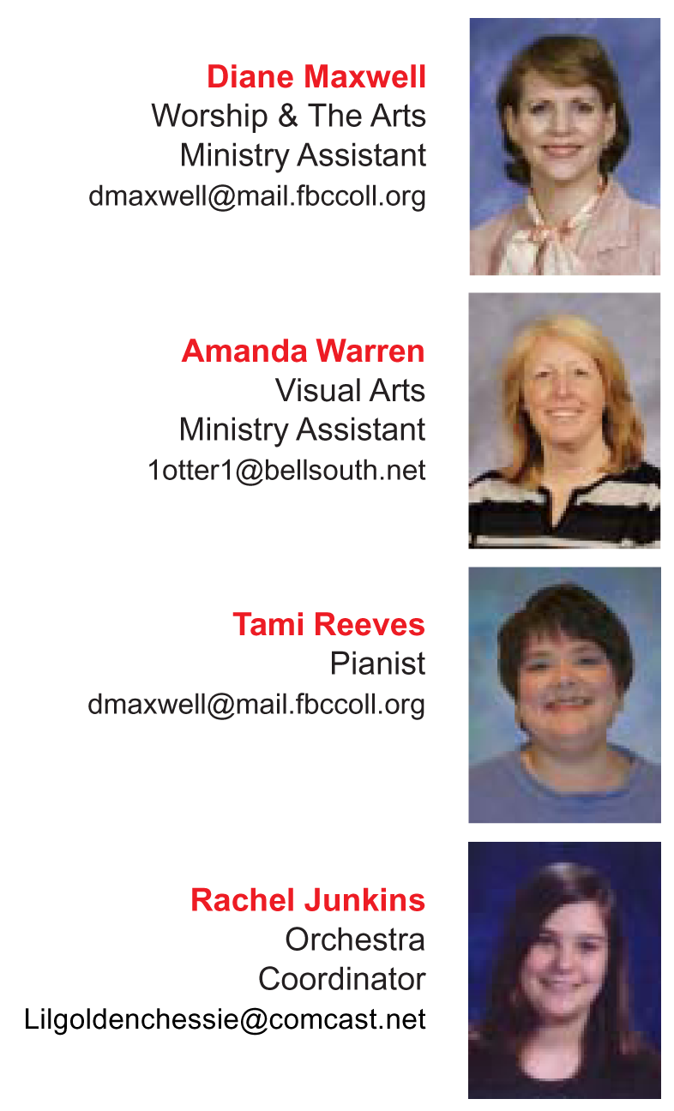

Music Ministry

General Information

Worship Choir
The Worship Choir & Orchestra are large groups open to any member or attender. The Choir is open to all attenders on a non-auditioned basis and sings regularly in weekend services and special productions. The Worship Choir rehearses each Wednesday evening from 6:45 until 8:15 p.m. in the Worship Center. For more information, contact Worship & The Arts Minister Tim Spencer by e-mail at tspencer@mail.fbccoll.org.

Worship Orchestra
The Worship Orchestra is composed of brass and woodwind players, and includes guitars, keyboards, a rhythm section and other instruments. The Orchestra plays regularly in weekend services and special productions. The Worship Orchestra rehearses each Wednesday from 5:30 until 6:30 p.m. in the Worship Center. Childcare is provided for both rehearsals and guests are always welcome! For more information, contact Instrumental Associate Minister Dom Fosco by e-mail at dfosco@mail.fbccoll.org.

Children’s Music
Recognizing the importance of training and discipling the “church of tomorrow” through music and the arts, we provide age-graded choirs both for preschoolers age three and up and children in grades one through five. Choirs meet at 6:00 p.m. on Wednesday evenings and sing regularly throughout the year. Children can register at the children’s area desk beginning at 5:50 p.m. Preschoolers can register at the preschool area desk beginning at 5:50 p.m. For more information, contact Children’s Music Associate Minister Laura Junkins by e-mail at ljunkins@mail.fbccoll.org.
Music Ministry
General Information

Ensembles & Choirs
Multiple ensembles and choirs meet weekly to prepare material for our weekly services. You can schedule an audition for an ensemble or request more information on a choir by calling 853-2668...
• Rejoice Ensemble—women’s group
• Redeemed Ensemble—mixed group
• First Light Ensemble—mixed group
• Sweet Memories Adults 55+ Choir
• Men’s Ensemble—men’s group
• Special Ensembles—trios, quartets
• Vocal Teams—worship ensembles

Soloists
Soloists are chosen from members of the Worship Choir & Orchestra. Soloists are expected to exhibit full devotion to Christ, a measure of performance skill, a teachable spirit and musical ability. If you have an interest in using your solo-quality talent, please schedule an audition with the Minister of Worship & The Arts.

Academy of Performing Arts
The ministry of the Academy of Performing Arts fills the important role of preparing musicians to lead in worship. Our vision is to build a strong Christian-based learning environment for musicians through excellence in music instruction.

The Academy registers students for Fall, Spring and Summer semesters. The semester schedule, along with academy tuition rates, are published online and in the academy brochures. For more information on private instruction in voice, piano, brass, woodwinds or strings, or for more on our preschool Music for Little Mozarts and MusikGarten programs, contact the Academy office at 853-2668, or e-mail us at apa@mail.fbccoll.org.
Theatre Ministry
General Information

Drama Team
The Drama Team is open to all attenders and members who have committed to growth as a follower of Christ. The Team is used in Sunday Celebration Services to illustrate and communicate weekly message themes. Whether or not you have a formal education in theatrical arts, consider a ministry in this group. Drama Open Houses for the team are scheduled in the Winter, Spring and Fall. Check the calendar for the next Drama Open House, or e-mail Suzy Spencer for more information at suzyspencer@bellsouth.net.

Spring Dinner Theatre
Open auditions are held each Winter for our Spring Dinner Theatre, usually presented three or four consecutive evenings in May. This ensemble cast production is an outreach ministry to our church and community.

Visual Arts Ministry
General Information

Set Construction Team
The Visual Team prepares visual set pieces for message series and special productions. The Team is open to any member or attender with artistic talent and construction experience, or to anyone with a general knowledge of set design, painting or sewing. For more information, contact Worship & The Arts Minister Tim Spencer by e-mail at tspencer@mail.fbccoll.org.
Technical Ministry
General Information

Sound Ministry Team
The Sound Tech Team has the important job of providing quality sound reinforcement for each week’s services. If you have experience or a willingness to learn, and a great “ear,” this might be the place for you! Contact Technical Director Tim Garner by e-mail at tgarner@mail.fbccoll.org.

Video Ministry Team
The Video Team is composed of video techs, editors and camera operators to produce live-feed and edited video segments for weekend worship services. The team provides a video feed to the Worship Service Overflow Room and to the Preschool Nursing Room during Sunday Morning Worship Services. Members of the group also meet as needed to film and compile assigned projects. Training time on the church’s production and switching equipment is required for new volunteers. To join the group, contact Video Team Leader Bob Salemi by e-mail at ssalemi@bellsouth.net.

KingdomFirst Media Ministry Team
The KingdomFirst Media Team is responsible for preparation and distribution of CD recordings of Sunday Morning and Evening Worship Service messages. The team also edits weekend services for broadcast on local Bott Radio affiliate WCRV. The teaching ministry of Dr. Chuck Herring can be heard each Saturday and Sunday at 9:00 a.m. on WCRV, AM 640. If you have the spiritual gift of service, this might be the team for you! Contact KingdomFirst Team Leader Richard Simmons by e-mail at dmaxwell@mail.fbccoll.org.
Worship Choir Information

Our Mission
We exist…to glorify God

by totally committing ourselves to
Jesus Christ and to the
explosive growth
of His kingdom.

Rehearsal Times
Worship Choir presently meets from 6:45 until 8:15 p.m. each Wednesday in the WORSHIP CENTER (our temporary rehearsal space). In late FALL 2008 we move into the new MUSIC HALL for Wednesday rehearsals and Sunday pre-service rehearsals.

Even if you have other commitments on Wednesday night, we encourage you to stay involved in the choir. All we ask is that you get to rehearsal as quickly as you can. If you have young children and need to leave before choir ends, we ask you to stay until our 8:00 p.m. prayer break.

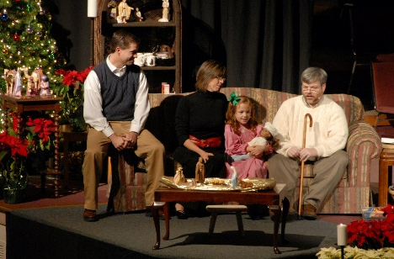
Worship Orchestra meets from 5:30 until 6:30 p.m. each Wednesday in the Worship Center (our temporary rehearsal space). In late FALL 2008 we move into the new ORCHESTRA SUITE for Wednesday rehearsals and Sunday pre-service rehearsals. We ask that you arrive on time at scheduled rehearsals.

Staying in Touch - The Call

Our weekly newsletter (The Call) is one of the ways we communicate with everyone in our Worship Choir and Orchestra ministry. That publication lists upcoming events, service programming, birthdays, prayer needs and important announcements. You can pick one up on Wednesday, but you’ll also receive one in the mail each week with updated prayer requests from the previous Wednesday night rehearsals. The current edition of The Call is also available each Thursday afternoon at the church’s web site: www.CFBConline.com.

Prayer Requests
We want to pray for the important needs in your life! Our new prayer request system, adopted by our choir officers, works like this:

- Write your request on the prayer boards when you arrive at rehearsal
- Your request will appear on the screens during choir rehearsal
- We will pray for each request silently or in groups at the conclusion of each Wednesday rehearsal
- Your request will be added to The Call before it’s mailed out on Thursday morning

This will keep our list updated and fresh and ensure that it doesn’t get too cumbersome. Remember, if you want a request to appear on The Call prayer list, you’ll need to write it on the prayer board each week. But if you’ll mark “repeated request” and the name of the person that prayer is requested for, you won’t have to write out the whole request each week. The repeated requests won’t appear on the screens on Wednesday nights, but they will be on The Call for that Thursday.

Please keep your written requests brief. There isn’t room for extensive information; plus, this keeps the prayer boards moving along and allows time for someone to type them into the computer so they can appear on the screens.

Childcare on Wednesday Nights
Childcare is provided each Wednesday night during both orchestra and choir rehearsals. Childcare instruction forms are available in the music suite. Fill out the form and turn it in to Diane Maxwell. After choir, pick up your children in the following locations: Babies - Nursery, 3-5 yr. olds - Room 1202, Grades 1-6 - Room 1204.

Childcare is also provided at major event rehearsals. Be sure to reserve your child’s place for special rehearsals on the childcare clipboard.

Sunday Worship Services
Worship Choir & Orchestra minister in the 9:15 & 10:45 a.m. Worship Services. Choir meets in the FELLOWSHIP ROOM ten minutes prior to the two services at 9:05 and 10:35 a.m. We encourage you to sing in both services if you can do so. If you have teaching responsibilities and cannot participate beyond the worship service you attend, we understand that.

Worship Orchestra meets for rehearsal at 8:30 a.m. each Sunday morning in Room 2215. Orchestra members walk downstairs to the Worship Center to tune and get set before the 9:15 a.m. Service.

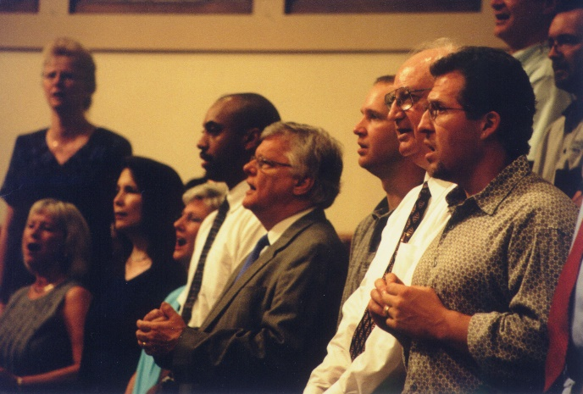

Memorization of Music
We recently made a commitment to begin memorizing the music we present in Sunday Worship Services. It improves our presentation, gives added punch to our singing (and volume) and helps us connect more personally with the congregation. There’s really no comparison between our sound when singing from memory and our sound when using music. The added power and cohesiveness we gain from music memorization is incredible!

If you’re not accustomed to memorizing your music, or if the whole idea makes you anxious, have no fear. You can do this! Here are a few tips for staying on top of your music memorization:
- Look Ahead – We publish a Sunday music schedule at each Open House event. Even though we sometimes have to change the schedule, it’s usually an accurate schedule. Look ahead to the upcoming selections we’ll be singing and start preparing…
- Listen to Your Practice CD – The practice CD we provide to you is a great resource for music memory. Listen to your CD in the car or on the way to work so the words will start to sink in.
- Practice Singing from Memory – As you sing a song in rehearsal, begin to gradually put the music down. Start with the chorus and repeated phrases and then move on to harder portions of the song.
- Use the Television Monitors – Watch the monitors in rehearsals. The words and other music prompts are there and you’ll be weaned from the music in no time.
- Watch the Director – Tim mouths the words and gives useful cues to the different sections. Most of the time, he’s even singing the right words…HA!
Open House Events
The Worship Choir is always open to new members! We provide three annual Open House rehearsals to give new members a preview of new music we’ll present in upcoming services and special seasonal projects we’ll present. Each Open House features a new music packet with rehearsal CDs along with service schedules, special project information and a great fellowship time.

Worship Choir Open Houses cover four-month seasons of ministry:
- Fall Open House: “Christmas in September” – Early September – We preview September to January music and prepare for our Worship Choir/Orchestra Christmas presentations.
- Spring Open House – Late January – We preview January to May music and prepare for our Palm Sunday Easter presentation.
- Summer Open House – Early May – We preview May to September music and prepare for summer projects.

Solos and Ensembles
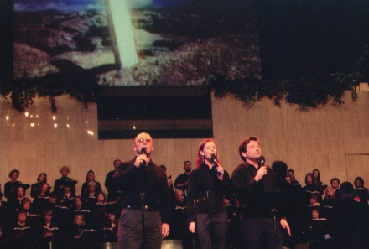
Soloists and ensemble musicians are chosen from members of the Worship Choir & Orchestra. In addition to consistent Worship Choir attendance, soloists are expected to exhibit full devotion to Christ, a measure of performance skill, a teachable spirit and musical ability. Open positions in existing and new ensembles are available periodically. If you have an interest in using your solo-quality talent in either ministry, please schedule a private audition with Diane Maxwell in the Worship & The Arts office.
Choir Outfits
We order Worship Choir outfits a couple of months before major presentations. Guys, you have it easy—fill out a form including your neck size and sleeve length, write a check for $30, and you’re done! You may provide your own black pants to wear with the black, banded-collar tuxedo shirt that we order for you. If you’d like to help one of our ladies (whose outfits run considerably higher) buy her outfit, you may consult Diane Maxwell about providing financial assistance.

Ladies, we wear black camisoles, black palazzo pants and a black, hand-beaded silk cape. The good news is that the camisoles and pants run quite large, so you may be able to order a smaller size than you generally wear! We have all sizes in stock for you to try on before you order. We will have a Wednesday rehearsal or two when we’ll have the sample garments available for you to try on before you fill out your order form.

The camisoles are $14 (sizes XXS-XL) to $19 (sizes 1X-4X); the cape is $49 (regular) to $64 (plus size); the pants are $29 (sizes XS-4X). A $50 deposit is due early, with the remainder due closer to our presentation date. Financial assistance is usually available, so just consult Diane Maxwell about this.
TOUCH Teams
(Touching Others Under Christ's Hand)
T- Touching
O- Others
U- Under
C- Christ’s
H- Hand
Romans 15:5-6 (NIV)
“May the God who gives endurance and encouragement give you a spirit of unity among yourselves as you follow Christ Jesus, so that with one heart and mouth you may glorify the God and Father of our Lord Jesus Christ.”

As Christians we are commanded in Galatians 5:13 to “serve one another in love”. As worship leaders we should be all the more diligent in setting this example by obeying and following Christ’s command in practical ways within the choir family. Our TOUCH teams were established to accomplish just that!

As brothers and sisters in Christ, we need each other to provide encouragement in the hard times and be able to celebrate together in the happy times (Rom. 12:15). Let’s be faithful to God’s commands in serving one another in love with our Worship TOUCH Teams!

Here’s what we’ll do to make sure every choir member is given an encouraging touch…

TOUCH Team Purpose—To facilitate Christian unity within the choir family by….
- Recognizing and celebrating significant life events such as…
  - Birthdays
  - Weddings
  - Births
- Providing encouragement during difficult life circumstances such as…
  - Extended Illnesses
  - Hospitalizations
  - Death in the family (death of choir member, spouse, child, mother or father of choir member)
  - Loss of Job

Here’s a summary of how it works
- Each month we’ll sign birthday cards for each member of the team that will be celebrating a birthday that month. These will be signed on the last Wednesday of the month following the rehearsal. Cards will be mailed each week by the TOUCH Team Director.

- Let your TOUCH Team Leader know of significant life events that you are celebrating so that your team can share in your joy!!
- Team members will provide meals for your family in the event of the birth of a child.
- Flowers will be sent in acknowledgment of your new addition!
- Also, team members may want to send a card to recognize other events in your life you are celebrating.

- Let your TOUCH Team Leader know of extended illnesses at home, hospitalizations, deaths in your family, or if you lose your job. These are the times that we want to show our love in a very real and personal way!
- The TOUCH Team Leader will inform the TOUCH Team Director of the illness, hospitalization or death in the family.
- The TOUCH Teams will then be mobilized to provide meals for your family.
- Flowers will be sent to provide encouragement in your illness or in your time of loss.
- TOUCH Team members may choose to be involved, individually, in other practical ways.
- In the event of job loss or other difficult circumstance, let your TOUCH Team Leader know so that your team will have the opportunity to help you through it.

TOUCH Team Leadership
TOUCH Team Director Duties
- Organize the choir roll into TOUCH Teams and update as needed throughout the year.
- Recruit TOUCH Team Leaders with assistance from the choir president.
- Compile and maintain a list of birthdays for each choir member.
- Mail any birthday cards or other cards collected from TOUCH Team Leaders each week.
- Assure that each TOUCH Team Leader has the appropriate number of birthday cards or encouragement cards, etc. needed for his/her TOUCH Team.
- Send out flowers in the event of a choir member’s hospitalization, birth of a baby or death of a family member, using funds collected from the choir.
- Inform Worship Ministry staff and choir president of hospitalizations, birth of baby, or death in the family of choir members.
- Coordinate with the Fellowship Director and TOUCH Team leaders to plan meals through the TOUCH Teams for hospitalized, bereaved, or new parent choir members.
- Fulfill the role of TOUCH Team Leader in the lives of each member of the TOUCH Team leadership.

TOUCH Team Leader
Length of Term
- A minimum of one calendar year (Jan. - Dec.).
- TOUCH Team Leader may volunteer to renew leadership at the beginning of the next calendar year
- Must inform TOUCH Team Director immediately if he/she needs to resign from leadership and agree to assist in recruiting a replacement.

Duties
- Have a maximum of 10-12 choir members for which he/she will be responsible.
- Assist TOUCH Team Director in compiling and maintaining a list of birthdays within his/her TOUCH Team.
- Have each member of the TOUCH Team sign birthday cards, etc. to be given to the TOUCH Team Director for mailing each week.
- Stay informed in regard to any significant life events or difficult circumstances that may arise within his/her TOUCH Team.
- Inform TOUCH Team Director of significant life events or difficult circumstances that may arise within his/her TOUCH Team.
- Help the TOUCH Team Director plan meals for members of his/her TOUCH team that have an extended illness/hospitalization or birth of a baby.

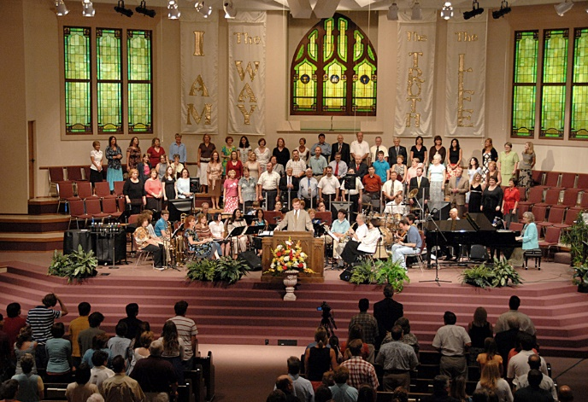

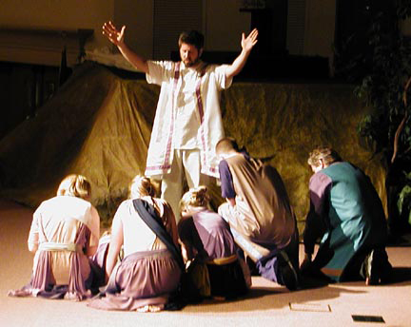

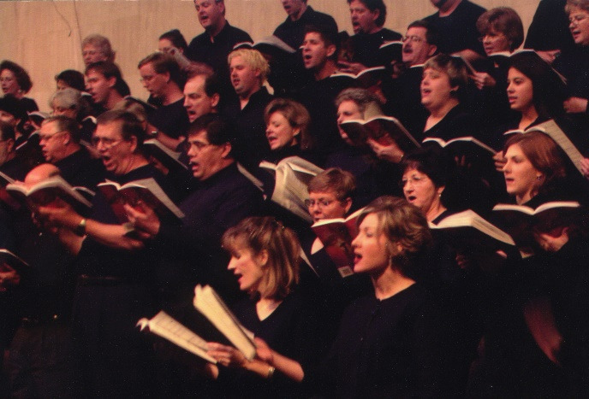

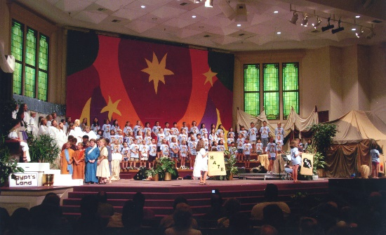
2008-2009 Calendar

Collierville First Baptist Church

April 2008
April 24th-26th - Spring Dinner Theatre,
6:30 p.m. Nightly
SUN April 27th - Adults 55+ Celebration Sunday
Sweet Memories Adults 55+ Choir Presentation, 6:00 p.m.
WED April 30th - Concert of Prayer, 7:00 p.m.
(No Choir; Orchestra Meets)

May 2008
SUN May 4th - Lord’s Supper Observance,
AM Services
Children’s Spring Fling, 6:00 p.m.
WED May 7th - Worship Choir/Orchestra
Open House, 5:30 & 6:45 p.m.
WED May 14th - Preschool Music Presentation,
6:00 p.m.
WED May 21st - M & M Night, 5:00-7:00 p.m.
(No Choir/Orchestra)
SUN May 18th - Graduate Recognition, AM Services
SUN May 25th - Memorial Day Weekend,
No Evening Worship Service
MON May 26th - Memorial Day, Church Office Closed

June 2008
June 9th-11th - Southern Baptist Convention,
Indianapolis, IN
June 23rd-27th - Vacation Bible School,
8:30-11:30 a.m. daily
July 2008
SUN July 13th - Lord’s Supper Observance,
6:00 p.m.
July 21st-25th - Children’s Music Camp,

“Pirates of the ‘I Don’t
Care’-ibbean,”
8:30 a.m.-2:30 p.m. daily
SUN July 27th - Music Camp Presentation,
6:00 p.m.

August 2008
SUN August 24th - “Somebody’s Praying Me
Through” Presentation – Worship
Choir & Orchestra, 6:00 p.m.
FRI August 31st - Labor Day Weekend
No Evening Worship Service

September 2008
MON September 1st - Labor Day;
Church Offices Closed
WED September 3rd - Wednesday Ministries Begin
SUN September 7th - Lord’s Supper Observance,
AM Services
WED September 10th - Worship Choir/Orchestra
Open House, 5:30 & 6:45 p.m.

October 2008
MON October 27th - Worship Equipment Move-in Begins (TENTATIVE)
WED October 29th - First Worship Rehearsals in New Worship Center/Worship Suite
(TENTATIVE)
FRI October 31st - Fall Family Festival,
5:00-7:00 p.m.

November 2008
November 3rd-7th - Tech/Worship Rehearsals
in New Worship Center (TENTATIVE)
SUN November 9th - WORSHIP CENTER OCCUPANCY (TENTATIVE)
November 10th-12th - Tennessee Baptist Convention
SUN November 16th - Capital Stewardship Gift
Community Open House,
3:00-5:00 p.m.
SAT November 22nd - Former Ministers Banquet,
6:30-8:00 p.m.
SUN November 23rd - GRAND OPENING
WORSHIP SERVICE (TENTATIVE),
10:00-11:45 a.m.
(No Bible Fellowships)
“The Gathering” Thanksgiving Meal
(Multi-Purpose Room), 5:00-6:30 p.m.
November 2008 (continued)
November 27th–28th - Thanksgiving Holidays;
Church Office Closed
SUN November 30th - Lord’s Supper Observance,
AM Services

December 2008
SUN December 7th - Children’s Choir
Presentation, 6:00 p.m.
SUN December 14th - Worship Choir/Orchestra
Christmas Presentation, 6:00 p.m.
DVD Grand Opening Ready for
Distribution (TENTATIVE)
SUN December 21st - “An Instrumental
Christmas” Presentation, 6:00 p.m.
December 24th-26th - Christmas Holidays;
Church Office Closed
December 31st-January 1st - New Year’s
Holidays; Church Office Closed

January 2009
WED January 7th - Wednesday Ministries Begin
WED January 14th - Music Conference Premiere
Rehearsal
January 15th-16th - Integrity Music
Conference, CFBC (TENTATIVE)
WED January 28th - Worship Choir/Orchestra
Open House, 5:30 & 6:45 p.m.

February 2009
SUN February 1st - Souper Bowl Service, 4:30 p.m.
SUN February 22nd - Lord’s Supper Observance,
AM Services

April 2009
SUN April 2nd - Palm Sunday Choir/Orchestra
30-minute presentation,
AM Services
THU April 9th - Lord’s Supper Service, 7:00 p.m.
FRI April 10th - Good Friday; Church Office Closed
SUN April 12th - Easter Sunday; No Evening
Worship Service

April 2009 (continued)
April 23rd-25th - Spring Dinner Theatre,
6:30 p.m. Nightly
(Multi-Purpose Room)

May 2009
SUN May 3rd - Children’s Spring Fling (Musical),
6:00 p.m.
WED May 6th - Concert of Prayer, 7:00 p.m.
No Choir; Orchestra Meets)
THU May 7th - National Day of Prayer Breakfast,
7:00-8:30 a.m.
WED May 13th - M&M Night, 5:00-7:00 p.m.
(No Choir/Orchestra)
SUN May 24th - Memorial Day Weekend,
No Evening Service
MON May 25th - Memorial Day; Church Office Closed

June 2009
June 15th-19th - Vacation Bible School,
8:30 - 11:30 a.m. Daily
June 21st-24th – Southern Baptist Convention,
Louisville, KY

July 2009
July 20th-24th – Children’s Music Camp,
8:30 a.m. – 2:30 p.m. Daily
SUN July 26th – Music Camp Presentation,
6:00 p.m. (Multi-Purpose Room)
Ensemble/Vocal Team/Soloists

Ministry Policies

Front-Stage Performers in Worship Services & Outreach Events

January 15, 2008

Purpose
Our primary purpose for our ensemble and vocal team ministry is facilitating congregational participation in both morning and evening Worship Services. We commit to model “spirit-and-truth” worship in an ensemble leadership setting.

Ministry Outline
Your team ministry provides worship leadership in Sunday morning worship services after the choir exits to the congregation, Bible study fellowship classes and other areas of ministry. Vocal teams and ensembles are an extension of the choir’s ministry, providing worship leadership when the full choir leaves the auditorium.

Teams are also used to facilitate Sunday evening worship. In the current format, ensembles and vocal teams will be used each Sunday evening, accompanied by the Rhythm Band at selected services.

Teams of vocalists rotate Sunday morning and evening responsibilities. Teams will be re-shuffled as needs arise and new members join the Worship Choir. Monthly team assignments will be mailed as soon as the schedule is set. Ensembles and teams will vary in composition, depending, in part, on experience, vocal part, voice quality and commitment record of choir members signing up for the ministry.

Ministry Policies
- Mission – We exist to glorify God by totally committing ourselves to Jesus Christ and to the explosive growth of His kingdom!

- Worship Choir Commitment – Vocal team members commit to 75% attendance at scheduled rehearsals and performances for the team/ensemble and for the Worship Choir. An absence is an absence for the purposes of the program and no distinction is made between “excused” and “unexcused” absences. The 75% attendance requirement allows for sickness and out-of-town trips (approximately one rehearsal and/or performance absence per month). Team ministry is set aside for the most committed choir and orchestra members.
- Dress Code – In order to focus the congregation’s attention on the message and substance of the worship time, team members agree to abide by the Worship Ministry Dress Code for any on-stage performances and worship services (see Worship Ministry Dress Code guidelines).
- Testimony – Vocal team members commit to model Christian behavior on stage and off. As worship leaders, we are called to higher standard of public and private Christ-like conduct. Please inform the Minister of Worship of any personal issues affecting your testimony to the church.
- Absences – As a courtesy, please inform the Worship & The Arts office of any upcoming absence. The Worship & The Arts office will then locate a substitute vocalist as needed.
- Duration – Vocal team ministry members commit to complete the current 1-month schedule of services.
Ensemble/Vocal Team/Soloist Ministry Commitment (FILE COPY)

Front-Stage Performers in Worship Services & Outreach Events

January 15, 2008

Purpose
Our primary purpose for our ensemble and vocal team ministry is facilitating congregational participation in both morning and evening Worship Services. We commit to model “spirit-and-truth” worship in an ensemble leadership setting.

Ministry Outline
Your team ministry provides worship leadership in Sunday morning worship services after the choir exits to the congregation, Bible study fellowship classes and other areas of ministry. Vocal teams and ensembles are an extension of the choir’s ministry, providing worship leadership when the full choir leaves the auditorium.

The Ensemble/Vocal Team/Soloist Commitment

I, ______________________________, commit to:

- Mission – Glorify God by totally committing myself to Jesus Christ and to the explosive growth of His kingdom!

- Worship Choir Commitment – Maintain at least 75% attendance at scheduled rehearsals and performances for the ensemble and for the Worship Choir and/or Orchestra.
- Dress Code – Abide by the Worship Ministry Dress Code for any on-stage performances and worship services (see Worship Ministry Dress Code guidelines).

- Testimony – Model Christian behavior, public and private.

- Absences – Inform the Worship & The Arts office of any upcoming absence.

- Duration – Complete the current 1-month schedule of services (for Vocal Teams only).

Signed, Ensemble/Vocal Team Member or Soloist

___________________________________

Signed, Ensemble/Vocal Team Director or Minister of Worship

___________________________________

Worship Ministry Dress Code

Front-Stage Performers

in Worship Services

Scriptural Foundations & Purpose
Our purpose for establishing a dress code for those who lead worship is to model Christian values and modesty for our congregation. What we choose to wear is a subjective choice for each of us, but certain basic guidelines are appropriate for men and women who take leadership roles on stage in worship services.

Our choices should be guided by certain Biblical principles. In that spirit, consider Scriptures that give principles and guidance in establishing a policy for appropriate dress for front-stage ministers:

1 Peter 3:3-4 (NKJV)
“³ Do not let your adornment be merely outward—arranging the hair, wearing gold, or putting on fine apparel— ⁴ rather let it be the hidden person of the heart, with the incorruptible beauty of a gentle and quiet spirit, which is very precious in the sight of God.”

1 Corinthians 6:19-20 (NKJV)
^{“19} Or do you not know that your body is the temple of the Holy Spirit who is in you, whom you have from God, and you are not your own? ²⁰ For you were bought at a price; therefore glorify God in your body and in your spirit, which are God’s.”

1 Corinthians 10:31-33 (NIV)
“³¹ So whether you eat or drink or whatever you do, do it all for the glory of God. ³² Do not cause anyone to stumble—³³even as I try to please everybody in every way. For I am not seeking my own good but the good of many, so that they may be saved.”
Our outward appearance should reflect what is in our hearts. To this end, even what we wear should bring glory to God. By dressing appropriately, we contribute to the right on-stage focus in our services and events.

In every respect, keep in mind that our goal is focusing the congregation’s attention on the message and substance of the worship time, not on any one person or performer. By dressing appropriately, we contribute to a God-centered focus in our services and events.

A condition of ministry at Collierville First Baptist Church is your agreement to abide by the church’s Worship Ministry Dress Code Policy.
Worship Ministry Dress Code Policy

Front-Stage Performers

in Worship Services

January 15, 2008

Purpose
Our purpose for establishing a dress code for those who lead worship is to model Christian values and modesty for our congregation. What we choose to wear is a subjective choice for each of us, but certain basic guidelines are appropriate for men and women who take leadership roles on stage in worship services.

In every respect, keep in mind that our goal is focusing the congregation’s attention on the message and substance of the worship time, not on any one person or performer. By dressing appropriately, we contribute to a God-centered focus in our services and events.

A condition of ministry at Collierville First Baptist Church is your agreement to abide by the church’s Worship Ministry Dress Code Policy.

Dress Code Policies - Men
- Ensemble, vocal team members and soloists commit to apply Biblical principles, modeling Christian behavior and modesty in the clothes worn for worship services and other on-stage performances.
- Appropriate Sunday morning attire for men includes sport jackets and suits, with or without ties. Appropriate Sunday evening attire for men includes dress pants, a collared shirt and dress shoes (at a minimum).
- Button-down shirts and golf shirts must be buttoned to the second button-hole from the shirt collar, unless the button holes are spaced more closely, in which case, we ask you to use good judgment.
- Men are not permitted to display nose or ear jewelry.
- Men should wear dress pants, as well as dress or casual shoes for all performances. Jeans, leather pants, or skin-tight clothing and tennis shoes are not appropriate for Sunday morning Worship Services or for Sunday Evening Worship Services.

Dress Code Policies - Women
- Ensemble, vocal team members and soloists commit to apply Biblical principles, modeling Christian behavior and modesty in the clothes worn for worship services and other on-stage performances.
- Women may wear business suits, slacks, dresses, skirts, blouses and other “business casual” outfits that are normally worn for church events and public meetings, etc.
- You will not be allowed to show cleavage on stage. Button-up blouses, dresses and other clothing items must be buttoned to the second button-hole from the shirt collar, unless the button holes are spaced more closely, in which case, we ask you to use good judgment.
- Skirts and dresses must be no shorter than two inches above the knee – we simply ask that you use your good judgment in choice of skirt length. Miniskirts and other “high-rise” skirts are not appropriate.
- Women are not permitted to display nose jewelry.
- Women should wear dress clothing for all performances. Jeans, skin-tight clothing and skirts, and tennis shoes are not appropriate for Sunday morning Worship Services or for Sunday Evening Worship Services.

Choir policy is to send flowers for a hospitalization, extended illness at home or birth of a baby for choir members—arrangement not to exceed $30.00. In the case of a death in the immediate family (see above), the choir will send an arrangement not to exceed $50.00.
An absence is an absence for the purposes of our ministry and no distinction is made between “excused” and “unexcused” absences. The 75% attendance requirement allows for sickness and out-of-town trips (approximately one rehearsal and/or performance absence per month). Ensemble/team ministry is set aside for the most committed choir and orchestra members.

